Use-Case Realization Report (Design)
Update Exam

Issue <1.0>
Revision History
Date | Issue | Description | Author
<10/Sep/09> | <1.0> | <Initial version> | <Thomas Yap>

Table of Contents
1. Brief Description 4
2. Flow of Events 4
2.1 Standard Flow 4
2.1.1 Update Exam 4
3. Interaction Diagrams 5
3.1 Collaboration Diagram for Update Exam 5
3.2 Sequence Diagram for Update Exam 6
4. Participating Objects 7
5. Class Diagrams 7
5.1 Class Diagram for Update Exam 7
6. Derived Requirements 7

Use-Case Realization Report
Update Exam

Brief Description
This use case enables the controller to update multiples choice question profile with its properties and parameters. It involves displaying the menu and form and search by search strings or list to update the data.

Flow of Events
The standard flow of events for this use case and any exceptions are described in the following subsections. The events are described in terms of Actors and Design Objects.

Standard Flow
This use case covers the Exam Maintenance - Update Exam. The standard flows of these events are described below.

Update Exam
The running of the application is shown in section 3.1. The flow of event is as follow:

- When the application start, the first operation to be performed is the startup operation of the main controller. This operation will create all the control objects and the entity objects necessary for operation Update Exam:
  - The control object created is: MCQBL Controller
  - The entity objects create are: mcq_exam_master and mcq_section_master
- The main controller will start the main function menu:
  - To start Update Exam, operation page_load() is activated by MCQBL Controller to display an Exam form.
  - PopulateExamList() will retrieve a title list of MCQ for Portal Admin to select to be displayed on Form ExamMaintenance.
  - Portal Admin is to change any details in the form. A confirmation request will be sent to the ExamMaintenance interface. Upon confirmation, the record will then be updated to tables using operation updateExam() and/or updateSetion() to entity object mcq_exam_master and/or mcq_section_master Table, if any.
  - The update request can be cancelled by clicking cancel button and no data will be altered. A confirmation message will be displayed by ExamMaintenance interface.

- Step 2 will be repeated until all updates are completed. Then controller will terminate the application by issuing operation close.

Interaction Diagrams

Collaboration Diagram for Update Exam
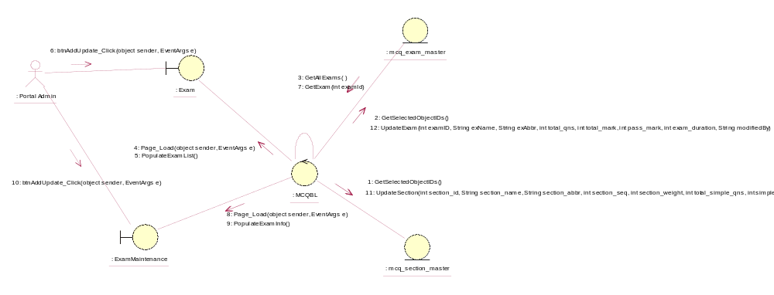

Sequence Diagram for Update Exam
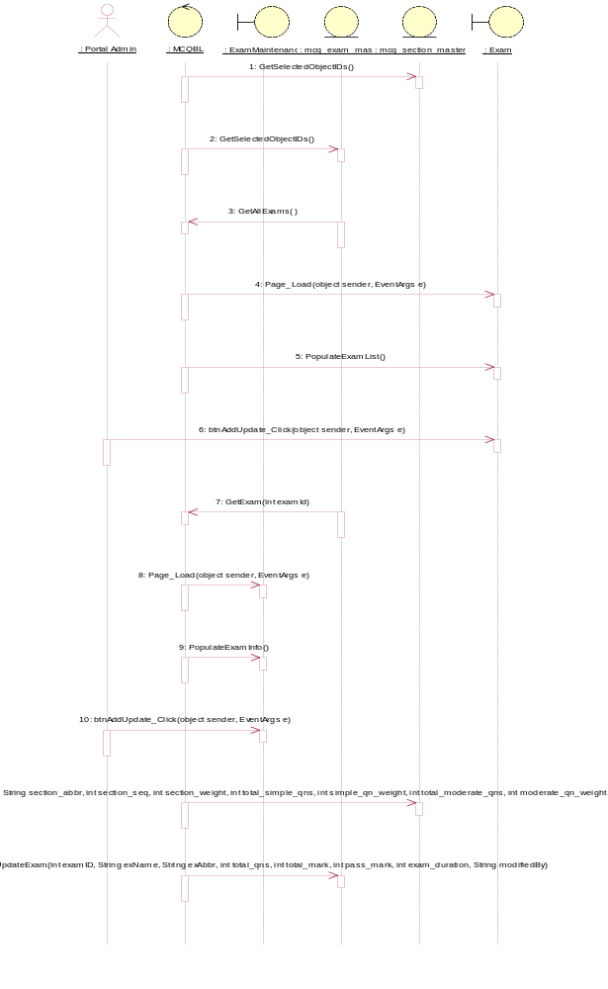

Participating Objects
: Exam

: ExamMaintenance

: mcq_exam_master

: mcq_section_master

: MCQBL

: Portal Admin

Class Diagrams

Class Diagram for Update Exam
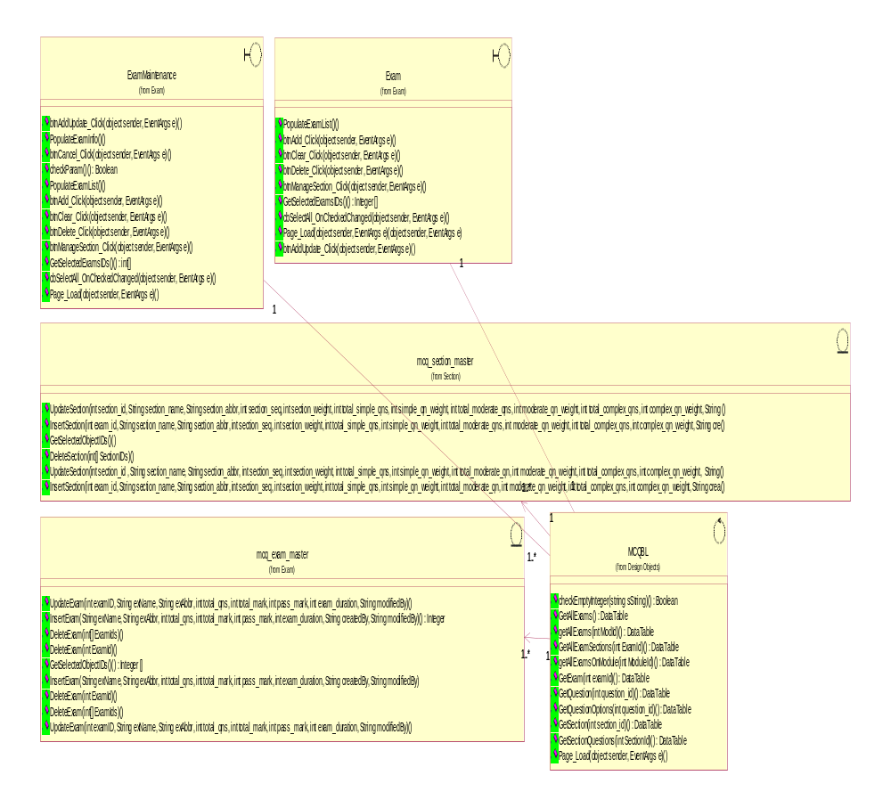

Derived Requirements
[enter the derived requirements here]

